## **KENYATTA UNIVERSITY**

# **SCHOOL OF PURE AND APPLIED SCIENCES**

## **CHEMISTRY DEPARTMENT**

# NAME: DIANA CHEPTOO

## REGISTRATION NUMBER: I73/0651/2018

# COURSE: BACHELOR OF SCIENCE IN ANALYTICAL CHEMISTRY WITH MANAGEMENT.

UNIT CODE: SCH 320

UNIT TITLE: INDUSTRIAL ATTACHMENT.

# TASK: INDUSTRIAL ATTACHMENT REPORT.

**i**

## **DECLARATION**

I, DIANA CHEPTOO, hereby declare that this report is my original findings and has not been plagiarized nor submitted for any academic award or other purposes.

Sign………………………………………. Date…………………………………..

## **SUPERVISORS**

Sign…………………………………………… Date…………………………………………

RIZIKI MWANDALU, Senior Research Scientist

Soil Department

Sign………………………………………….. Date…………………………………………

EMMANUEL MAKATIANI, Senior Research Scientist

Biotechnology Department

**ii**

## **ACKNOWLEDGEMENT**

First, I want to thank the almighty Father for seeing me through the three months attachment period and for giving me good health.

I also want to thank my two supervisors Emmanuel Makatiani and Riziki Mwandalu who oversaw my work during the attachment period and guided me when I needed it. May God bless you and your family abundantly.

My sincere regards also go to Shadrack Odhiambo laboratory manager at the soil science department and his entire team for their patience, guidance, and encouragement throughout the attachment period. Your efforts are not left unseen and may God bless you abundantly.

I also want to pass my gratitude to my university supervisor Dr. Harun Mbuvi for taking the time to come and assess me and also to my course coordinator Dr. Alphonse Wanyonyi for his guidance before and during the attachment period May God bless you.

I also want to thank my fellow students who were on attachment together for their friendliness and cooperation. May God bless every one of you.

**iii**

### **DEDICATION**

I wish to dedicate this work to my grandparents who stood with me in my academic journey and gave me all the support I needed during this attachment period. I love you so much and may God give you long life to see His goodness.

**iv**

**ABSTRACT**

The report entails the activities I undertook during the three months attachment period from 6th June 2022 to 9th September 2022 at KENYA FORESTRY RESEARCH INSTITUTE (Kefri) and its overall structure. The main objective was to put into practice the theoretical skills I learned in class for the last four years. It includes the departments I chose which were relevant to my course study and included the Biotechnology lab which I attended for 3 weeks and the Soils lab which I attended for nine weeks. I learned about tissue culture, rhizobium culture, mycorrhizal association, and nematology in the Biotechnology lab. in the soils lab, I learned a lot and it included the following; procedure of cleaning of apparatus, soil texture, determination of both macro and microelements in soil and plants samples using Atomic Absorption spectroscopy, determination of total nitrogen and phosphorus using Ultra-violet visible spectrophotometer, total carbon, determination of pH and electroconductivity of the samples, and employed phytoremediation approaches in the nursery. I gained a lot of skills and experience during the attachment period some experiences were new but others I had learned in class.

**v**

**TABLE OF CONTENTS**

Title page…………………………………………………………………………………………………………...i

Declaration………………………………………………………………………………………………………….ii

Acknowledgment……………………………………………………………………………………………………iii

Dedication………………………………………………………………………………………………………………..iv

Abstract……………………………………………………………………………………………………………………..v

CHAPTER ONE

Introduction……………………………………………………………………………………………………1

1.0 attachment and objectives………………………………………………….

* 1. Kefirefri background and history…………………………………………………………………………..
  2. Overview of kefir…………………………………………………………………………………………..
  3. Thematic areas………………………………………………………………………………………
  4. Mandate……………………………………………………………………………………………………
  5. Vision………………………………………………………………………………………………………….
  6. Mission………………………………………………………………………………………………………..
  7. Core values…………………………………………………………………………………………………

CHAPTER TWO

2.0 Administrative structures

2.1 Ranks and positions…………………………………………………………………………………..

2.2 kefri centers…………………………………………………………………………………………………

CHAPTER THREE

AREAS COVERED

3.0 Biotechnology lab

3.1 Rhizobium culture………………………………………………………………………………………..

3.2 Tissue culture……………………………………………………………………………………………..

3.3 Extraction of spores…………………………………………………………………………….

3.4 Polymerise chain reaction…………………………………………………………………………..

# 3.5 Nematology……………………………………………………………………………………………..

3.5 Soil science

3.6 Cleaning of apparatus…………………………………………………………………………….

3.7 Soil texture…………………………………………………………………………………………….

3.8 Atomic Absorption Spectroscopy…………………………………………………………………..

3.80 Theory of AAS………………………………………………………………………

3.81 Determination of macro elements………………………………………………..

3.82 Determination of microelements……………………………………………………….

3.9 pH and electroconductivity………………………………………………………………………………..

4.0 Total nitrogen………………………………………………………………………………………………..

4.1 Determination of phosphorus………………………………………………………………………..

4.2 Total carbon…………………………………………………………………………………………..

4.3 Phytoremediation approach…………………………………………………………………..

CHAPTER FOUR

4.4 Achievements ……………………………………………………………………………………..

4.5 Conclusions…………………………………………………………………………………..

4.6 Bibliography………………………………………………………………………………..

## **CHAPTER ONE**

### **INTRODUCTION**

**ATTACHMENT**

SCH 320 is a unit in Bachelor of science Analytical chemistry with management in the school of pure and applied sciences. It is a requirement unit that is aimed at equipping students with skills required in the field of analytical chemistry. The fields include; spectroscopy, acid-based methods, potentiometry, and chromatography. These skills allow students to apply them in different relevant workplace environments.

Kenya forestry research institute gives students a platform to put into practice what they learned in class in the relevant departments. I have been equipped with the above skills, especially in the soil science laboratory and Biotechnology lab. I had good supervisors who oversaw my work in each department. I was also assessed by my university supervisor after two months who got to know my performance with the help of the internal supervisor.

**OBJECTIVES**

The objectives were as follows:

* To put into practice the theory I learned in class
* To gain experience in my field of study as an analytical chemist
* Get exposed to the kind of equipment used in analytical chemistry
* To get to know the kind of employers I expect in my field of study
* To know the kind of challenges I may experience in my field of study

**KEFRI BACKGROUND AND HISTORY.**

Kefri was established as a state corporation in 1986 under the Science and Technology Act chapter 250of the laws of Kenya to focus on forestry research. The act was repealed by the science, technology, and innovation Act No 28 of 2013. It is also mandated under the forest Conservation and Management Act, 2016 to undertake forestry research.

**Overview of Kefir**

KEFRI undertakes research and provides technologies and information for sustainable management, conservation, and development of forests and allied natural resources. It is ISO 14001:2015 Environmental Management Systems (EMS) and ISO 90001-2015 Quality Management Systems (QMS). Certified and therefore conforms to international standards on environmental and quality national legislations and its research meets international standards.

Kefri headquarters is located at Muguga Kikuyu, Kiambu county. It has 5 regional centers for research programs with head offices in Gede, Kitui, Muguga, Londiani, and Maseno. It has one national research forest products research center located at Karura.

**Thematic Areas**

* Forest productivity and improvement (FPI)
* Biodiversity and environment management (BEM)
* Forest products development (FPD)
* Socio-economic policy and governance (SPG)
* Forestry research and support services (FRSS**)**

These thematic areas are supported by finance and administration departments.

**Mandate**

* Conduct research in forestry and allied natural resources.
* Disseminate research findings to stakeholders.
* Build capacity of stakeholders.
* Establish partnerships and cooperate with other research organizations and institutions of higher learning in joint research and training.

**Vision**

A world-class center of excellence in forestry and allied natural resources research for sustainable development.

**Mission**

To conduct research and provide information and technologies for sustainable development of forestry and allied natural resources for socio-economic development.

**Core values**

* Teamwork
* Healthy environment
* Professionalism
* Partnership
* Innovation
* Creativity
* Customer focus

# CHAPTER TWO

## Administration structure

### 

# **CHAPTER THREE.**

## **AREAS COVERED**

**BIOTECHNOLOGY LABORATORY**

I was introduced and oriented by Mr. Makatiani to the lab. I did the following topics practically:

## Rhizobium culture

Rhizobium is a nitrogen-fixing bacterium found in leguminous plants. The following process is followed during culturing:

* Uprooting of a leguminous plant to obtain nodules from the field.
* Washing the nodules using ethanol followed by hypochlorite and the three sets of distilled water.
* The nodules are the crushed
* Prepare the media (contents of the media mannitol, dipotassium phosphate, magnesium sulfate, sodium chloride, yeast extract, agar, stains, congo red, and bromothymol blue.
* Place the media into Petri dishes in a fume chamber for 72 hours
* Striking the solid 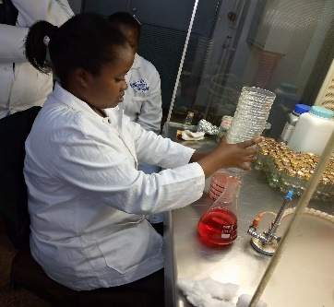media to inoculate the samples.

### Tissue culture

It involves shoot culture using developed seeds for example Melia volkensii, and bamboo. Melia volkensii have pods that are hard to break and if broken destroys the embryo. Bamboo takes over a hundred years to flower hence the lab do tissue culturing of these plants for commercial purpose. the following steps are followed;

* Shoot induction
* Shoot multiplication
* Root induction
* Hardening stage
* Acclimatization stage
* Taken to the field

### Extraction of spores

Spores are used in the manufacture of fertilizers, and growing of pines and are used to prepare inoculates. Spores are extracted from the soil. The soil is placed in a beaker and washed using a strong jet of water. They are then sieved using a 4.5 sieve. The residue is placed in centrifuge tubes and left to settle. The supernatant is got rid of and 48% sucrose is added and mixed. Spores will settle at the top. Spores are viewed using a microscope.

### Polymerase chain reaction

PCR is a test used to detect genetic material from a specific organism such as a virus. It is used to amplify DNA to obtain millions of copies of a target. The following steps are followed;

* nonstepep- the solution is heated to at least 94 degrees Celcius using a thermal cycler. The heat breaks the hydrogen bonds of the original DNA sample and separates the DNA into single strands.
* Annealing step- the sample mixture is cooled to between 50 degrees Celcius to 60 degrees Celcius allowing the DNA primers and the DNA polymerase enzyme to bind to the individual strands of DNA that were separated by the heat.
* Extension step- once joined together, they form a new complementary strand of DNA. Thus, a new duplicate double-stranded DNA molecule has been formed from each of the single strands.
* Final elongation- performed at a temperature of 70-74 degrees Celcius for 5-15 minutes. It is done to ensure that any remaining single-stranded DNA is fully extended. It ensures complete polymerization.

### Nematology

Is a scientific study of nematodes. There are different types of nematodes and including Rhabditea, Meloidogyne, pratylenchus, Ditylenchus, and Tylenchida. Some are bacterial feeders, fungal feeders, omnivores, plant parasites, and predators. These nematodes feed on the plants and damage the root system reducing the ability to absorb water and nutrients. We had a practical session where we went to a nearby farm and collected affected plants by female Meloidogyne. We extracted the eggs by keeping the roost in 5% hypochlorite. We then smashed the roots to get nematodes, sieved them, and viewed them using a microscope.

**Pictures**

## Hybridization

It is the concept of mixing two different genes of plants to obtain a plant with a better trait. It produces new genetic combinations and is the norm in cross-pollinated plants. Examples of cross-breed plants include pine and eucalyptus. Hybridization includes pollen collection, pollen harvesting, pollen extraction, drying, storage, and pollen testing. Stages of hybridization include pre-anthesis, anthesis, emasculation, stigma, pollination, and isolation.

### Mycorrhizal associations

They are symbiotic associations whereby both the plant and the fungi benefit from each other. Plants provide sugar to the fungi and fungi obtain nutrients and water from the soil for the plants. Types of mycorrhizal include arbuscular and ectomycorrhizas. Identification includes staining to see infection for arbuscular and ectomycorrhizas in the fruit bodies.

# **SOIL SCIENCE DEPARTMENT**

I was introduced to the soil science lab and the instrumentation room. I was also taken through the equipment used which includes UV-vis, furnace, and AAS, and a summary of all the events in the soil science lab. The following is a flow chart showing a summary of events;

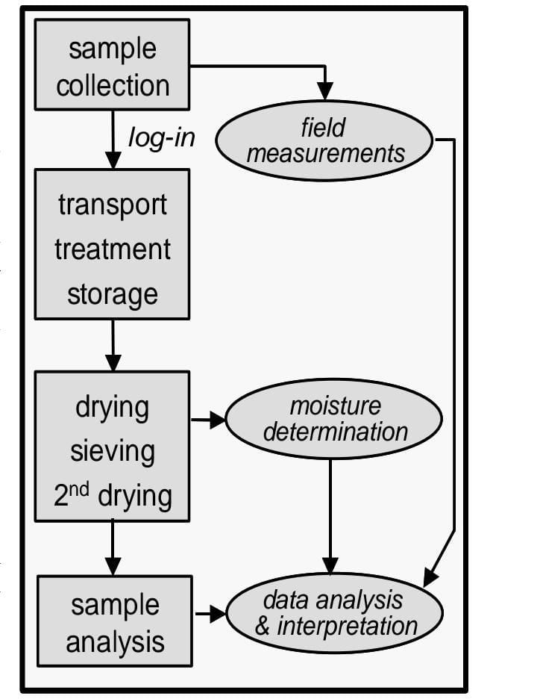

**Physical laboratory**

The following happens in the physical lab

**Air drying**- this is the removal of excess moisture. It results in new or stronger organic matter and mineral interaction. It also increases hydrophobicity and mineral surface-surface acidity.

**Testing of physical properties**- include bulk density which indicates compaction and soil health, soil texture which determines characteristics that affect plant growth and moisture through evaporation and plant transpiration, and moisture content which is key in controlling the exchange of water and heat energy between the surface and atmosphere.

**Drying-** to obtain the right weight

**Grinding**- to increase the surface area

**Sieving**- to gain finer particles

All of the above activities take place in the physical lab under the soli science laboratory.

### **Cleaning of apparatus**

The following procedure is followed when cleaning apparatus in the laboratory;

* Sample disposal into the right bin
* Rinsing apparatus with cold water
* Washing using soap and warm water
* Rinsing with tap water
* Rinsing with distilled water
* For glass apparatus place them in the oven to dry and for plastics, they are airdried

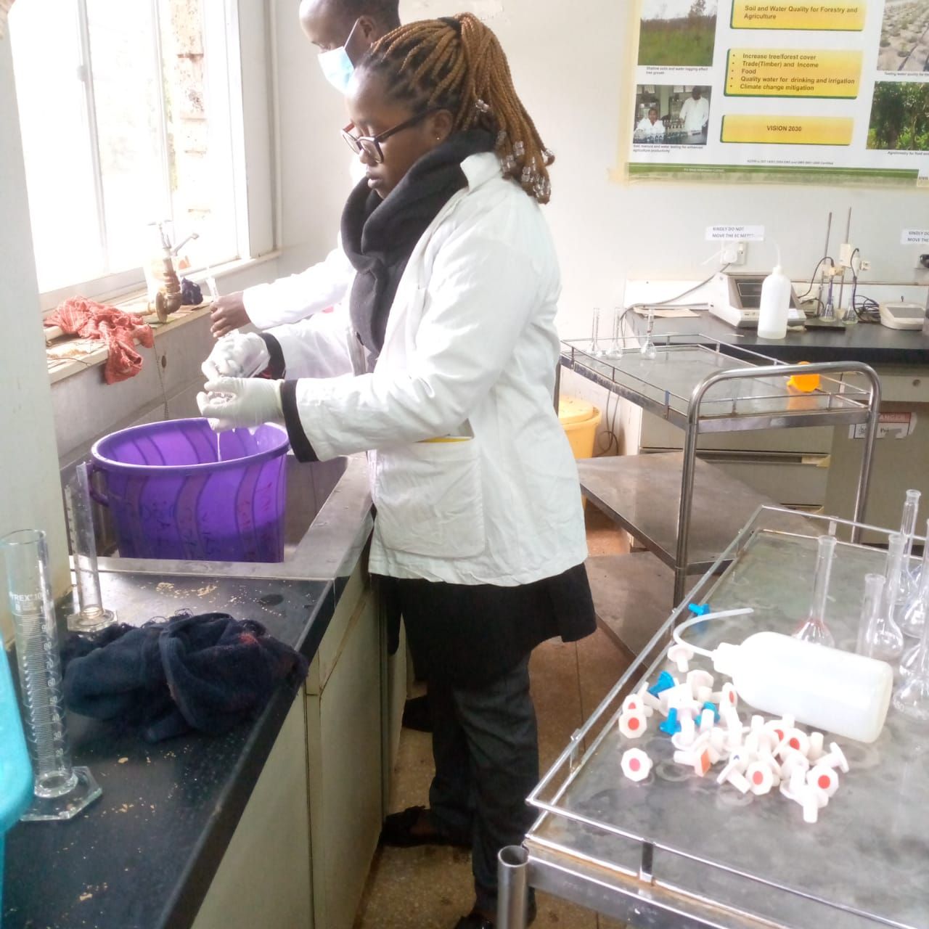

One must wear gloves and a protective face mask while washing the apparatus as a precaution.

### **Soil texture**

It is a classification instrument used in both field and laboratory soil classes based on their physical texture. It estimates the percentage of sand, silt, and clay contents of the soil and is reported as a percentage by weight of oven-dry organic matter-free soil. It helps in managing the nutrition the plants receive, determines the characteristics of soil that affect plants’ growth, influences nutrient retention, and controls water holding capacity. The following is a procedure taken when determining soil texture;

1. Weigh 50g of soil samples and transfer them into a bottle
2. 50ml of Calgon is added followed by 300ml of water
3. Place in the shaker and leave it overnight
4. Transfer to a 1000ml measuring cylinder and top up with tap water
5. Use a plunger to agitate the mixture for 2 minutes.
6. Deep the hydrometer and take the reading after 40 seconds. This is the determination of sand.
7. Second reading is taken after 2 hours without agitating the mixture for clay measurement.
8. Do calculations to obtain silt; sand +clay +silt=100

Reading-blank=x

Weight-x= sand measurement

The soil texture triangle is used to determine the type of soil

Soil texture triangle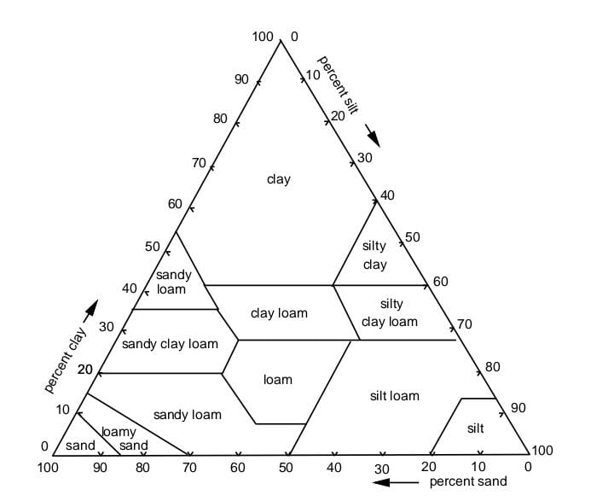

## **Atomic absorption spectroscopy**

It is an analytical technique used in measuring the concentration of metallic elements in soils and plant samples. When a metallic salt is introduced into a flame, an atomic vapor is formed and some of the atoms may be raised to higher energy levels so that excited atoms can relax by emission of radiation from a specific element. Its principles steps are as follows;

* Evaporation of solvent leaving a residue
* Vaporization of solid with dissociation into constituent atoms
* Thermal radiation absorption by gaseous atoms to go to an excited state
* Emission of the absorbed radiation

**Instrumentation of AAS**

**Hollow cathode-** the source of radiation of the specific element of interest

**Sample holder**- holds the sample

**Electro-thermal atomizer provides** enhanced sensitivity

**Monochromators**- isolate the wavelengths of interest from a broad spectrum of wavelengths emanating from hollow cathode lamps.

**Detector**- it uses a photomultiplier tube that converts incident light to an electrical signal

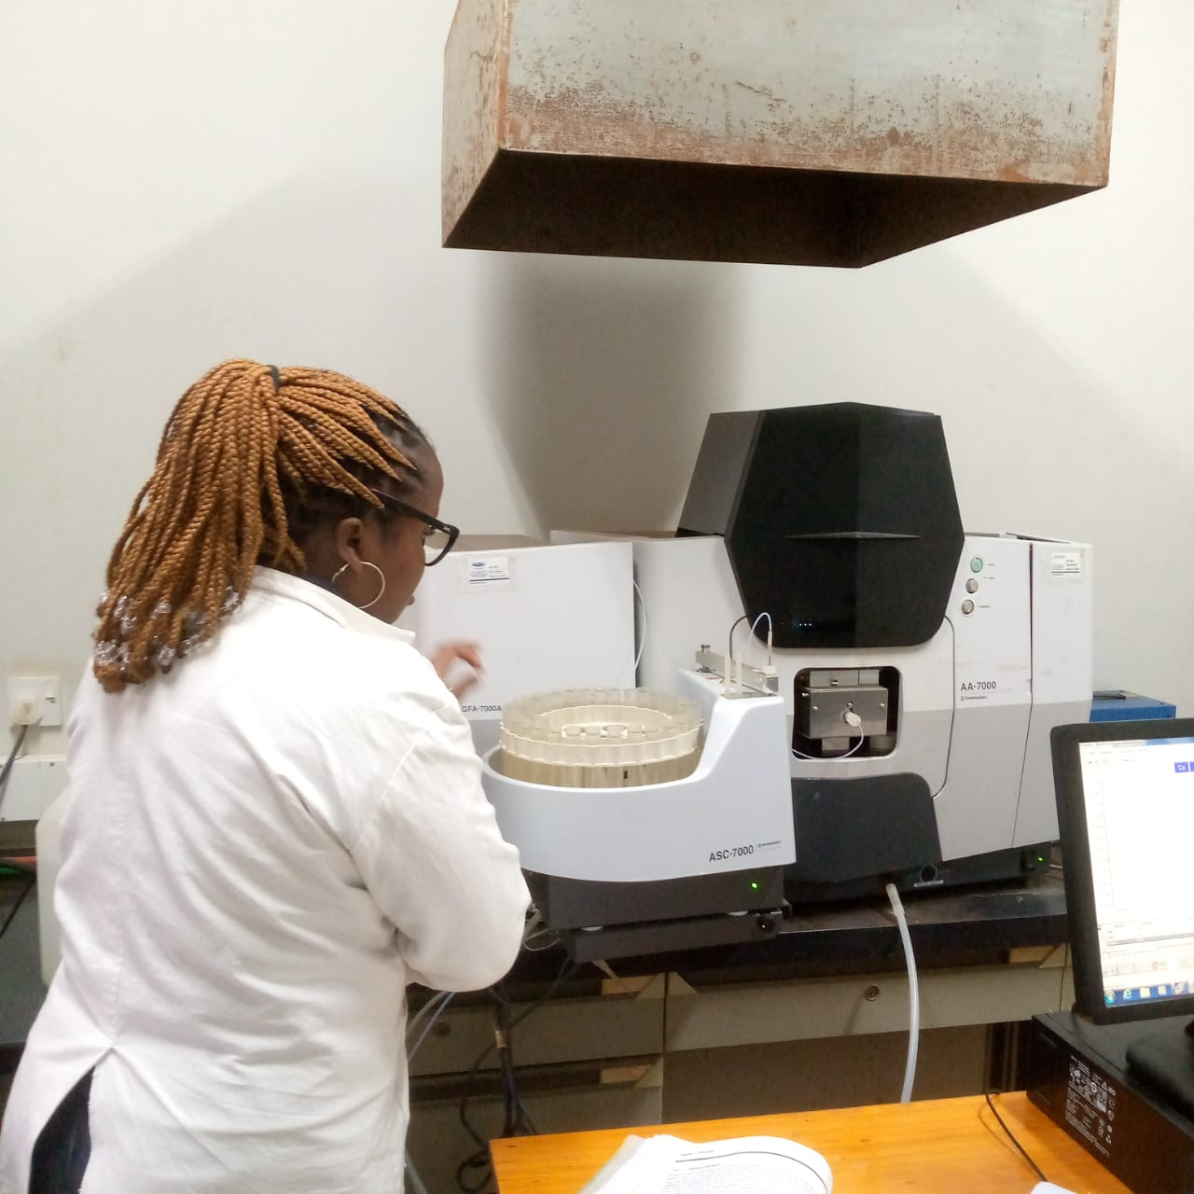

AAS equipment during analysis

**Determination of macro-elements using AAS**

The soil extract solution must be diluted 10 times to full within a measurable range of the flame photometer and AAS. 5ml of the soil extract solution was then pipetted into a 50ml volumetric flask. 1 ml of 26.8% lanthanum chloride solution was added and diluted to the mark using 1M NH4OAc which is used as an extracting agent where the maximum exchange occurs between the NH4 and cations originally occupying exchange sites on the soil surface. Lanthanum or strontium is added as a releasing agent to prevent the formation of refractory compounds, which may interfere with determination. The solution is sprayed into the flame for the determination of the compounds. The standard solutions are first measured to calibrate the instrument. Calcium is usually in high concentration in the soil and requires much dilution.



Calculations K, Ca, Mg = ( a-b) * v * f * 1000



1000 * W

**Determination of micro-elements using AAS**

The elements are trace elements that plants obtain from the soil. Small amounts are required for healthy growth. Soil test values serve to predict deficient conditions of soils and to indicate how much is required to ameliorate a given situation since they are of low concentration in soils the requirement of micronutrients. It is necessary to determine their accurate levels in soils. Ethylenediamine tetraacetic acid is used as a chelating agent to determine their concentration. A suspension of 1% EDTA and soil forms a metal-chelate ionic complex. When these complexes are subjected to acetylene flame in AAS they are atomized and absorb radiation of element-specific wavelengths. This is the basis for the analysis of trace elements. 5g of soil samples are weighed and placed in a bottle. 50ml 1% EDTA is added and shaken in a mechanical shaker for 1 hour. It is filtered and taken to AAS for determination.

Calculation of Cu, Mn, Zn and Fe = (a-b )* v* f* 1000



1000 * W

### **pH** **and Electroconductivity**

pH is expressed as a universal log of hydrogen ion concentration. The pH of the soil solution controls the form and solubility of many plant nutrients.

Electroconductivity measurement identifies soil that is potentially saline. The electroconductivity of saturated paste extract is measured to determine the level of salinity. 325g of soil is weighed into a plastic container, water is then added while stirring until saturation. It is then allowed to stand for hours to permit the soil to imbibe the water and then more water is added to the mixture is then allowed to stand overnight and the criteria are rechecked for saturation. The mixture is then transferred to a Buchner filter funnel with highly retentive filter paper. The conductivity is measured against that of standards and categorized as saline or non-saline.

### **Total nitrogen**

The content of total nitrogen is measured in digest obtained by treating soil and plant samples with hydrogen peroxide, sulphuric acid, selenium, and salicylic acid. The principles take into account the possible omission of nitrates by coupling them with salicylic acid in the acid media to form 3-nitrosalicyclic and 4-nitrosalicyclic. The compound is reduced to corresponding amino acid forms by the soil organic matter. The analysis of total nutrients requires complete oxidation of organic matter. Hydrogen peroxide oxidizes organic matter, selenium acts as a catalyst, and sulphuric (iv) acid completes digestion of elevated temperatures. In total nitrogen, o.3g of soil samples are weighed and placed in a clean digestion tube and labeled. 4.4ml of digestion mixture is added and reagent blanks for each batch. It is then left for two hours and left to cool for one hour. 25ml of distilled water is added and mixed and then topped up to 50ml. Concentration is determined using UV-vis and recorded.

Calculation N = c * v * f

W

c- the corrected concentration

v- volume of the digest

f- dilution factor

w- weight of the sample

### **Total carbon**

Crucibles are dried in the oven overnight. They as then placed in the desiccator as they are weighed. About 10g of the soil samples are weighed and placed in the crucibles in the desiccator and the weight is recorded. They are then placed in the muffle furnace at 550 degrees Celsius for 5 hours. Calculations are done using the differences in the weight of the crucibles before and after combustion.

Ash% = ( w3 – w1 ) / ( w2 – w1 ) * 100

Organic matter % = 100 – ash%

W1- the weight of the empty dry crucible

W2- the weight of the dry crucible containing the sample

W3- the weight of the dry crucible containing the sample after ignition.

### **Determination of phosphorus**

10ml 0f the standard solution, 10ml of each soil extract, and 10 ml of blanks were pipetted into a 50 ml volumetric flask. About 20ml of distilled water was added and 5ml of 8.8M H3BO3 followed by 10ml of ascorbic acid. It was then topped with distilled water and shaken well. It was then left for two hours and ten the intensity of color was analyzed at 880nm using UV-vis. The calculation was as follows;

Pmg Kg-1 = ( a-b) * v * f * 1000

1000 * W

1. Concentration of Pmg in extract
2. Concentration of Pmg in the blank

v- extract volume

w- the weight of the dried sample

f- functional dilution factor

The calibration curve plotted concentration against the absorbance of the standard series reading for P in Pmg per liter. The above analysis is done without pH adjustment.

### **Principle of ultra-violet visible spectroscopy**

Spectroscopy is based on the interaction of light with matter. Matter absorbs light and then undergoes excitation to fall back which results in the production of a spectrum. It is based on the absorption of ultraviolet or visible light by a chemical compound which results in distinct spectra. Matter jumps from ground state to higher state. The energies of the ground state and the excited state of the electron are always equal to the amount of ultraviolet radiation or visible radiation absorbed it. It is used in the field of analytical chemistry, especially in the identification of specific analyte quantities. It can also be used to carry out solid and gaseous analytes in some conditions

## **Phytoremediation approach**

A study was done by Mary Gathara, John Otuoma, and James Ndufa at kefri in the laboratory and glasshouse to assess the capacity of selected trees to mop up heavy metals from the soil and the effect of heavy metals on their growth performance. It entailed the growing of trees species in the soil samples collected from heavy metal contaminated sites which include Macalder in Migori gold mines, Rostaman in Kakamega gold mine, Ondiri swamp in Kiambu industrial effluent, and Nairobi River in Nairobi. The concentration of heavy metals in the plant tissues was to be assessed over time to determine the capacity of each tree to absorb heavy metals. A control was set up in the glasshouse using sand with known concentration levels of NPK nutrient solution. The control of sand was free of heavy metal. We helped in the set up of the glasshouse and planting of the sample trees. The project is ongoing and a conclusion is yet to be made.

# **CHAPTER FOUR**

## Research activities from other institutions

We had a student from the university of Reading in England, Bonnie Marie who undertook research concerning the contribution of different land use systems to nutrient cycling and carbon stocks in the soil science laboratory. We collected the samples which included soil and leaf litter from the bamboo plantation, farm, and forest plantation. We did all the analysis of the soil and leaf litter and a conclusion was made by the student.

### Achievements

* I gained experience of what I had learned in class which was the main objective of the industrial attachment. learned how to operate AAS, UV-VIS, and pH meters. I was also able to carry out soil texture, and total carbon analysis using a muffle furnace. This was a great opportunity for me to practice how to use some of these instruments.
* I was able to create a network in my field of study and know who my employers are and what I should expect after my graduation.
* It also exposed me to the kind of challenges I expect in my field of study. The main challenge was the expensive reagents and maintenance of the equipment which is also very expensive.
* It also helped me to improve on my time management which made sure I was always on time to work.

### Challenges encountered

The main challenge was coping with the weather which was very cold compared to where I previously lived.

### Conclusion

In conclusion, industrial attachment is a good opportunity for students to practice skills required in their area of study. It nurtures one to be a prepared individual when dealing with work pressures and challenges. I, therefore, recommend industrial attachment to all students.

### **List of abbreviations**

Kefri – kenya forestry research institute

EDTA- ethylenediamine tetra acetic acid

AAS – atomic absorption spectroscopy

Uv-vis- ultra violet visible

pH – potential of Hydrogen